TeleHealth visit instructions:
About 10-15 minutes prior to your scheduled appointment time you will be called by a veterinary team member.
  - You will be asked pertinent background information on your pet during this time (similar to in-person appointments).
  - During this time, we will collect payment information and you will receive a text message link for a TeleTails video chat.
The following text message should appear, and you should perform the following steps to accept the video call:
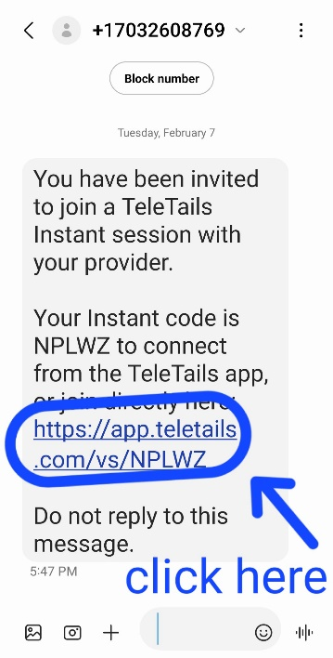
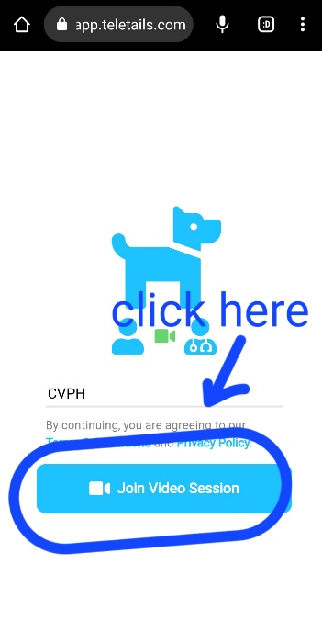
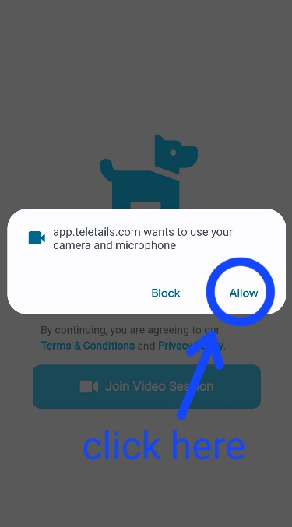
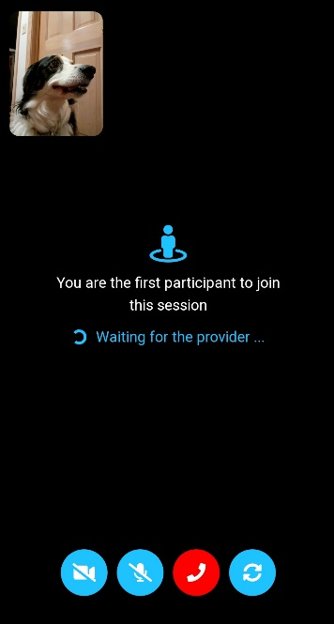

Your provider will then join the video chat shortly.

Following the conclusion of the video chat, simply click the red phone icon to end the video call.

